**The Crime Reports**

The purpose to analyze the recent history of crime in Austin Texas from 2017 – 2020, and to see if there was any correlation of crimes relative to the surrounding environment. Our Hypothesis is that the highest crime levels in Austin Texas are centered around areas of ill repute. We will be utilizing the Austin crime data to map out locations of crimes and utilizing Google’s API to mark surrounding venues such as liquor stores, bars, etc.…

We aim to have a heatmap of Austin showing its any growth, shrinkages, or migration of crime in a specific city area over the course of the historical study. We also aim to use the Google data to mark or cluster pins to identify venues of reproach that may contribute to crime and violence; and to confirm our hypothesis that is highest in areas filled with these types of stores.

**Links to Data Set and Screenshots of Metadata:**

Austin Crime Data: https://data.austintexas.gov/Public-Safety/Crime-Reports/fdj4-gpfu/data

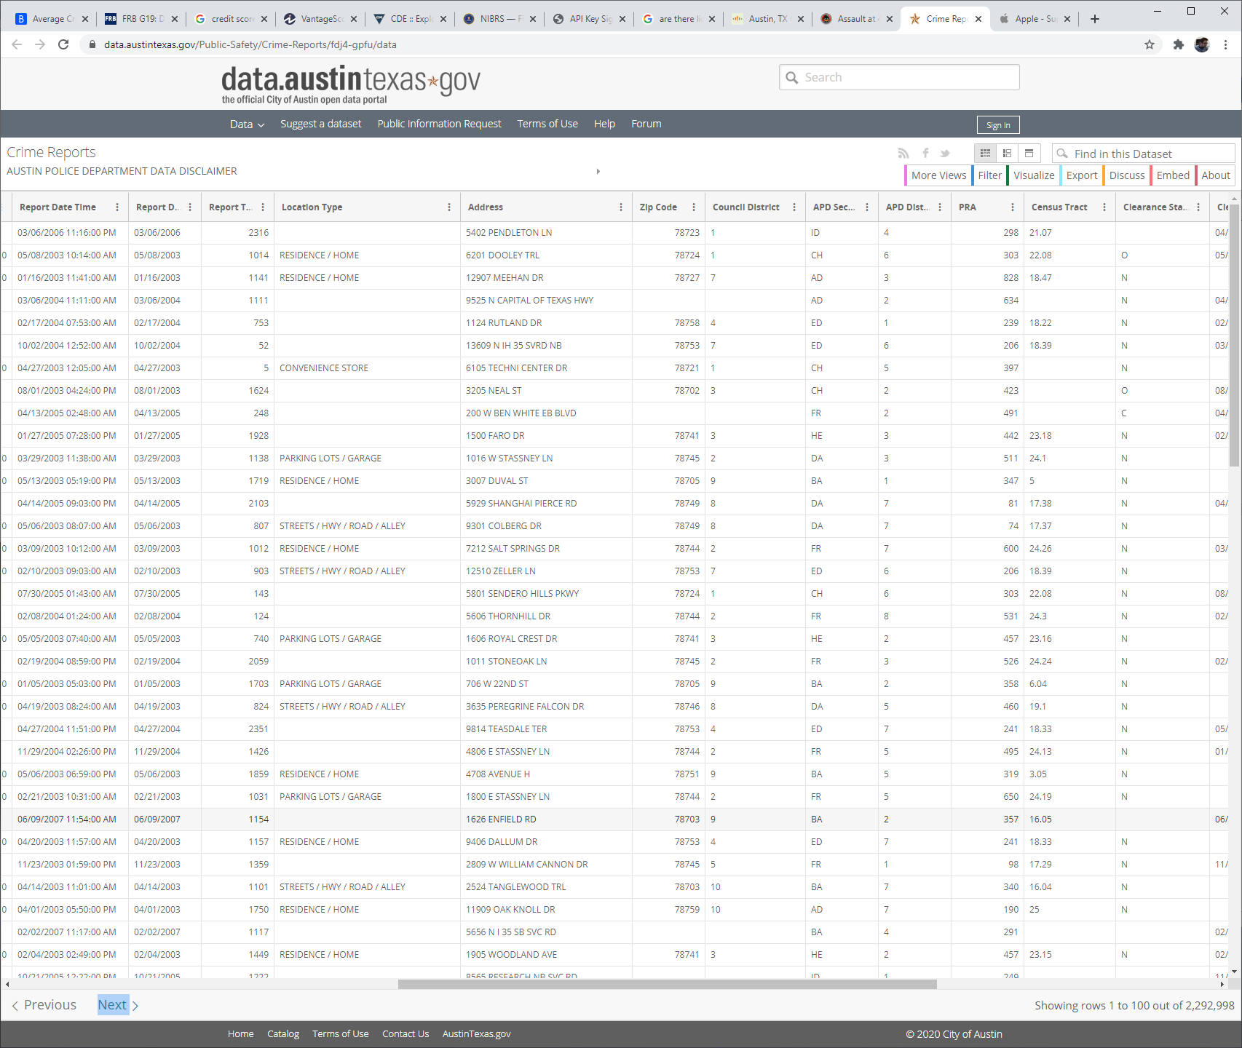

**Sample of Visualizations:**

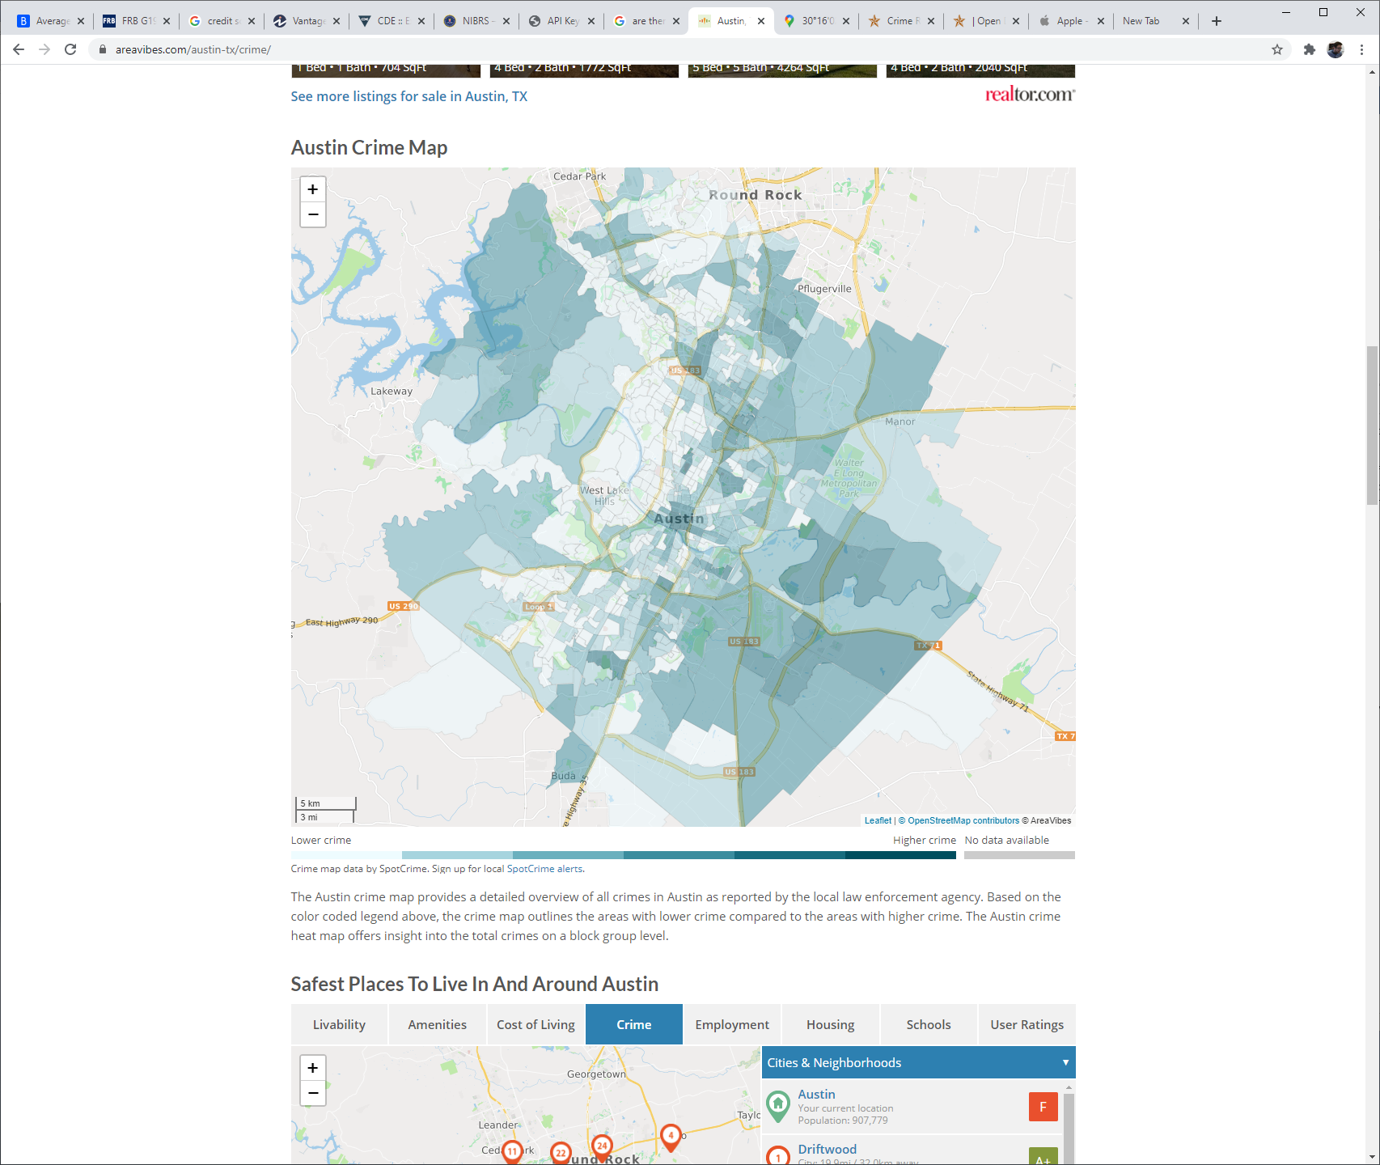

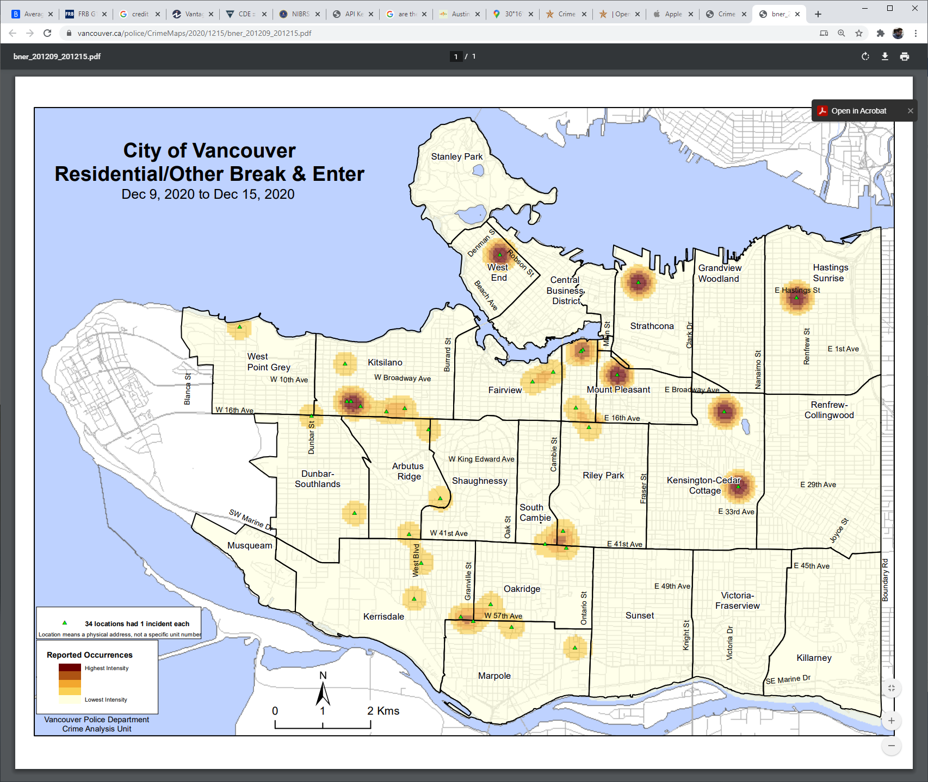

**Links to GitHub Repository:**

https://github.com/abstatz/Project-3